Architecture

Resources :
The Elegance of Modular Data Processing with Python’s Pipeline Approach | Dawid Kraczkowski
- Domain and Pipeline registry.pptx
- Strategie für Rapid Prototyping.pptx
- Domain and Pipeline registry.pptx
- Pipeline.pptx

Architecture
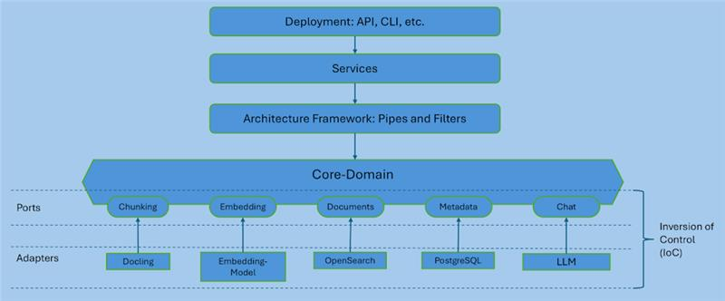

System design
The backend follows a clean, domain-driven, ports & adapters + pipeline architecture. Think of it like this:

The big picture: layers and responsibilities
The dependency flow is:
Client → API → Application → Pipelines → Domain → Ports → Adapters → Infrastructure
a) API Layer (backend/api/)
- FastAPI routes/controllers live here.
- Responsibilities:
  - Define HTTP endpoints (e.g. POST /documents/upload).
  - Validate requests, parse query/body.
  - Handle HTTP-specific stuff (status codes, headers).
- The API must not talk directly to DBs, HTTP clients, Docling, etc. It only calls application services.
b) Application Layer (backend/application/)
- Contains “use case” orchestrators, e.g. a DocumentsApplicationService or IngestionApplicationService.
- Responsibilities:
  - Coordinate a full use case like: “User uploads a file → extract text → chunk → embed → store”.
  - Build a pipeline, create a context object, and execute it.
  - Call domain services and pipelines, but never raw infrastructure.
Think of it as: “When someone calls this endpoint, what is the business flow we want to execute?”
c) Pipeline Layer (backend/pipelines/)
- Generic mini-workflow engine. It lets you chain multiple steps.
- Core engine lives in backend/pipelines/core/:
  - Pipeline
  - PipelineStep / AsyncPipelineStep
  - PipelineCursor / context types
- Domain-specific steps live in backend/pipelines/steps/ (or filters/ depending on naming).
- Each step is small and focused, e.g.:
  - DoclingExtractionStep → “Call the text extractor port”
  - ChunkDocumentStep → “Split long text into chunks”
  - EmbedChunksStep → “Call embedding service”
  - StoreDocumentStep → “Persist to DB/vector store”
Pipelines themselves don’t own business rules; they orchestrate domain services and ports.
d) Domain Layer (backend/domain/)
- This is the core business logic.
- Contains:
  - models.py – entities, value objects (e.g. Document, Page, Chunk).
  - services.py – domain rules (e.g. “how we pre-process text”).
  - ports – interfaces that describe what the domain needs from the outside world.
- Crucial rule: Domain depends on NOTHING external:
  - No FastAPI, no HTTP libraries, no DB drivers, no Docling SDK…
  - Only on Python standard lib and its own ports.
For you, the interesting part is: there will be a domain port for “Document Text Extraction” that your Docling adapter will implement.
e) Ports & Adapters
- Ports live in backend/domain/ports/. They are protocols/interfaces like:
  - SearchClient, ChatLLMClient, DocumentRepository, etc.
- Adapters live in backend/adapters/ and implement those ports:
  - e.g. backend/adapters/search/qdrant_client.py might implement SearchClient.
- Adapters are allowed to talk to infrastructure (HTTP, DBs, external APIs).
- Domain never knows whether the adapter is calling Qdrant, Docling, or something else – it just sees a port.
f) Infrastructure Layer (backend/infrastructure/)
- Low-level integrations: HTTP clients, DB clients, vector stores, etc.
- Often you’ll see:
  - infrastructure/external_services/ with ports.py + concrete HTTP clients.
  - infrastructure/storage_clients/ with DB or blob storage implementations.
Adapters typically depend on these infra clients to actually “do things”.

